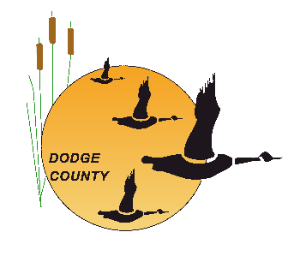
HUMAN SERVICES & HEALTH DEPARTMENT
199 County Road DF, Juneau, WI 53039

DRUG SCREENING
ECONOMIC SUPPORT - SUPPORTIVE SERVICE AUTHORIZATION

CASE # DATE OF REQUEST:
INDIVIDUAL:
ADDRESS/CITY/ST/ZIP:
PHONE:
DOB:
AGENCY GRANTING SUPPORTIVE SERVICE:
DODGE COUNTY HUMAN SERVICES & HEALTH DEPARTMENT
PHONE: 920-386-3760
FAX: 920-386-4012
ESS WORKER:
SERVICE PROVIDER (Primary Testing Site): Dodge Co. DTC, 199 Cty Rd DF, Ground Flr, Juneau
IF SECONDARY SITE IS NEEDED, PLEASE CHOOSE FROM THIS LIST: Choose an item.
FUNDING SOURCE: FOODSTMP (FoodShare)
SERVICES REQUESTED: 7-panel drug test
PRIMARY Testing Site (Juneau): SEND RESULTS TO: HDOB, 2nd Floor Reception
Secondary Testing Sites (Beaver Dam, Watertown): SEND RESULTS TO: CDPU, PO Box 5234, Janesville, WI 53547-5234; FAX: (855) 293-1822

SEND INVOICE TO: Dodge County Human Services and Health Department
Attn: Chrystal Begovatz
199 County Road DF, 2nd Floor
Juneau, WI 53039-9512
- - - - - - - - - - - - - - - - - - - - - - - - - - - - - - - - - - - - - - - - - - - - - - - - - - - - - - - - - - - - - - - - - - - - - - - - - -
DATE SUPPORTIVE SERVICE GRANTED: VALID THROUGH
ESS WORKER SIGNATURE:
APPROVAL SIGNATURE:

